Name: Yash Raj
Roll Number: 24k-0737
Task#1:
Code:
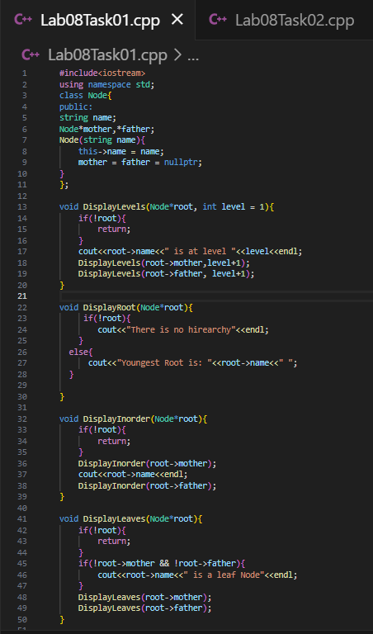
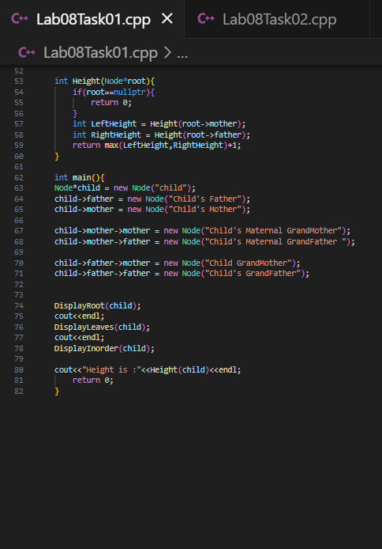
Output:
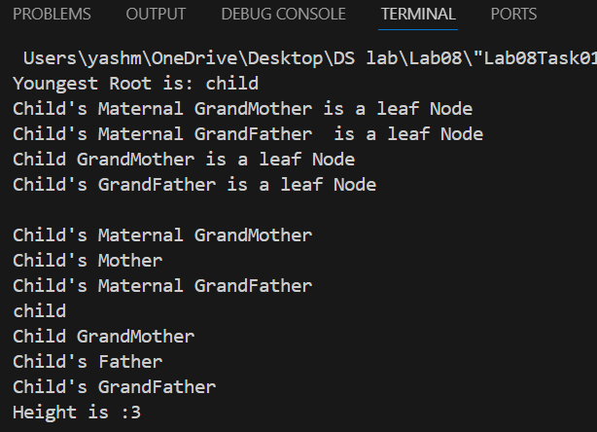
Task#2:
Code:
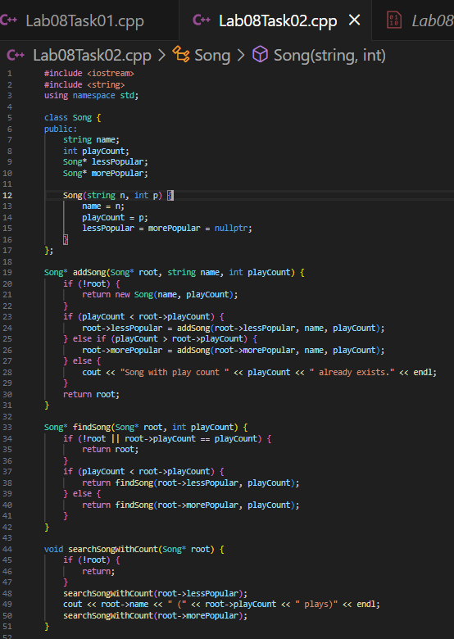
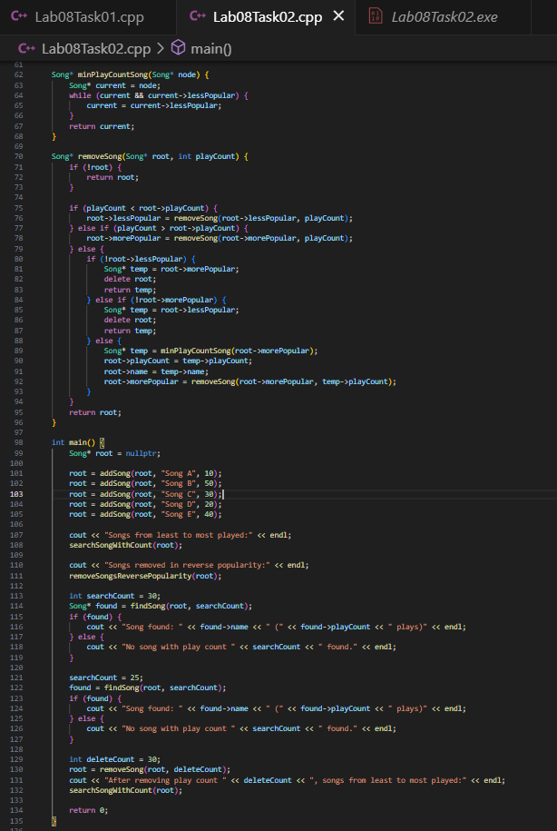
Output:
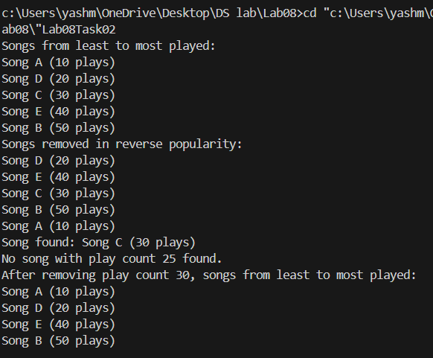

Note: I have also uploaded these tasks on the github and here is the repo’s link :
https://github.com/Yashraj608/DS-Lab-BCS-H-YashRaj/tree/main

